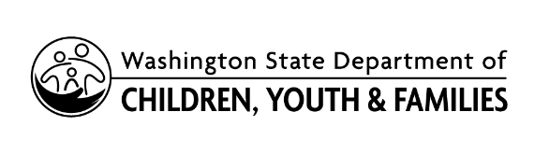 | State Approved  Training Concern Form
Complete this form if you have had an unsatisfactory experience with a state-approved trainer or training and would like to express your concern to the Department of Children, Youth, and Families (DCYF). More information about the Trainer/Training Concern policy and procedure in the Professional Development Policy Manual. Submit complete form to training@dcyf.wa.gov.
SECTION 1: APPLICANT INFORMATION
Last Name | First Name | Middle Name | Date of Birth (mm/dd/yyyy)
STARS ID | Phone Number | E-mail
SECTION 2: TRAINING DETAILS
Name of state-approved trainer and Trainer ID:

Title of training attended:

Training Start Date (mm/dd/yyyy) |  | Training End Date (mm/dd/yyyy)
SECTION 3: CONCERN DETAILS
Please provide a detailed description of your concern, including specific examples.

SECTION 4: STATEMENT OF UNDERSTANDING (Signature Required to Process Request)
The information I provided is true and accurate. I authorize the DCYF to enter this information into the Managed Education and Registry Information Tool (MERIT), a secure system owned and operated by DCYF. I understand that:
- Information shared with DCYF becomes public record and some information in public records is available to the general public upon request.
- All forms and documentation submitted to DCYF will become the property of DCYF.

Signature_________________________________________ Date __________________

