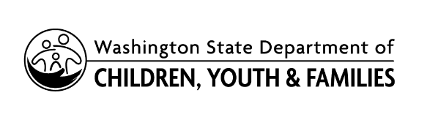 | Employment Verification For  State Approved Training
This form verifies employment status. You must have this form signed by a qualified representative who can attest to your affiliation with the institution. Send completed form to the Professional Development Team at training@dcyf.wa.gov.
SECTION 1: APPLICANT INFORMATION
Last Name: |  | First Name: |  | STARS ID:
Phone Number (home): |  |  | Phone Number (business):
Email:
SECTION 2: EDUCATIONAL CREDENTIALS
Applicants must demonstrate award of at least a Bachelor’s degree or higher in any field.
Degree: |  |  | Major/Area of Study:
Year Awarded: |  |  | Total Credits:
Degree: |  |  | Major/Area of Study:
Year Awarded: |  |  | Total Credits:
Degree: |  |  | Major/Area of Study:
Year Awarded: |  |  | Total Credits:
SECTION 3: INSTITUTION INFORMATION
Name of Institution:
Name of Department:
Address:
City: | State: |  | Zip Code: |  | County:
SECTION 4: AREA(S) OF INSTRUCTION
Please list the area(s) of instruction and/or training you provide as part of your primary role.

SECTION 5: QUALITY ASSURANCES & ACKNOWLEDGEMENTS

- By signing this document, the department authority of the institution affirms the current employment status at the institution.
- Approval as a trainer in this capacity does not imply that the institution is responsible for the training provided during the approval period. Training provided outside of the institution is advertised as being provided by the approved trainer as an independent trainer and requires a state UBI number and/or affiliation with a given organization.

I, certify that the above information is true and I understand all assurances as outlined above.

Signature |  | Date (mm/dd/yyyy)

