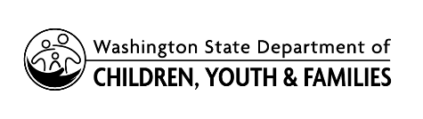 | LICENSING DIVISION (LD)  Compliance Agreement for Child Placing Agency (CPA)

AGENCY INFORMATION
NAME OF CPA |  | PROVIDER NUMBER
CPA DESIGNEE NAME

ADDRESS | CITY |  | STATE  WA | ZIP CODE

RELATED INTAKE (IF APPLICABLE)

INTAKE NUMBER | PROVIDER ACTION NUMBER
Click outside of table to add rows as needed and the delete this text.

WASHINGTON ADMINISTRATIVE CODE (WAC) | NONCOMPLIANCE DESCRIPTION/SUMMARY | PLAN OF CORRECTION | DUE DATE
Select WAC

Copy and paste table as needed above this line and then delete this text.

LD LICENSOR SIGNATURE
I approve this plan of correction.
LD LICENSOR NAME

LD LICENSOR SIGNATURE | DATE

AGENCY SIGNATURE
I agree to provide verification that I have corrected the issue(s) of noncompliance cited above as outlined in the plan of correction by the dates indicated.
CPA DESIGNEE NAME

CPA DESIGNEE SIGNATURE | DATE

LD LICENSOR SIGNATURE
I received verification that the issue(s) of noncompliance cited above have been corrected.
LD LICENSOR NAME

LD LICENSOR SIGNATURE | DATE

