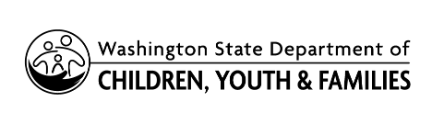 |  | Release and Consent for  Child Specific Recruitment
Case Number: | Caseworker Name: |  | Child Name: | Date of Birth:
Region: | Office |  | Program: | Phone:
Address: | City: |  | State: | Zip:

I/We, | , give consent to have the following types of
Parent Name(s)
recruitment initiated on behalf of the above-named child for finding:
An adoptive family A foster family
I understand only the child’s first name will be used and no confidential information regarding the child’s background is released as part of the profile.

Please check all items for which you gave consent:
Newspaper | Television | Photo profile websites & Recruitment Programs
Local Area Only | Local Area Only | Northwest Adoption Exchange (NWAE)
Any Geographic Area | Any Geographic Area | WA Access through NWAE (password protected website)
Non-local Area Only | Non-local Area Only | NWAE In-Depth Profiles (public website)  Wendy’s Wonderful Kids (WWK)
Consortium
Yes
No

May we use the child’s photograph and/or video images: YES NO
Local Area Only Any Geographic Area Non-local Area Only

Comments/Additional Information:

*The Division of Children, Youth, and Families will search for a family willing to consider an Open Adoption Agreement with the child’s parent(s). Both parents must agree and sign. If only one parent agrees, a court order must be obtained to allow for recruitment services.
Parent Signature |  | Print Name |  | Date
Parent Signature |  | Print Name |  | Date
DCYF Caseworker Signature |  | Print Name |  | Date

