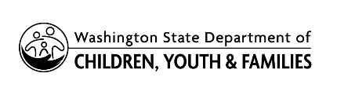 | Local Indian Child Welfare Advisory Committee  Confidentiality Agreement

I understand that as a volunteer member of the Local Indian Child Welfare Advisory Committee team, I may learn of case specific, confidential information about children or families.
I agree to hold in strict confidence all child-specific or identifying information regarding children and families served by the Department of Children, Youth, and Families (DCYF) as required by RCW 13.50.100, RCW 74.04.060 and applicable federal laws.
I understand that if I release this confidential information in violation of a child or family’s confidentiality I will no longer be invited to volunteer as a member of the Local Indian Child Welfare Advisory Committee team.
Signature Date

Print your name here

