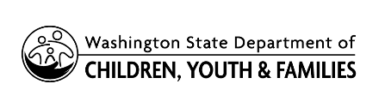 | Authorization By Subject of Records Requested

By signing below, I authorize the State of Washington Department of Children, Youth, and Families to release my confidential information about the existence of any founded findings of child abuse or neglect to the requesting individual, agency or organization identified on the Child Abuse and Neglect Founded Findings Request.

Subject’s Signature |  | Print Name |  | Date

