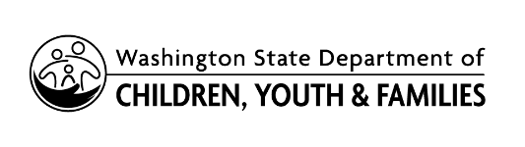 | ECEAP & Early ECEAP  Parent & Family Voices (PFV)  PFV Representative ("Rep") Recruitment

DCYF-ECEAP is recruiting for ECEAP and Early ECEAP parent/family volunteers to join the PFV group. This group of PFV Reps will provide input and feedback on statewide ECEAP and Early ECEAP issues related to policies, practices, and standards. PFV Reps will receive orientation, support, and communication from the DCYF-ECEAP team.

NOTE: This form is to be completed by a Family Services Staff or other ECEAP program staff, along with the interested Parent/Family Rep.
After the form is submitted, a DCYF-ECEAP team member will be in contact with the Family Services staff and the interested Parent/Family Rep, with further information.
Thank you!
Begin Parents & Families Voices interest form below.

- Name of the interested Parents & Families Voices (PFV) Representative:

- Email address of the interested PFV Representative (if available)

- Name and Email address of ECEAP/Early ECEAP/ staff person completing this questionnaire:

- Name of the ECEAP / Early ECEAP / Contractor (or subcontractor), name of the site, and city the site is in:

- Which program (s) are you and your family in?
ECEAP
Early ECEAP
Both ECEAP and Early ECEAP

- For the interested Parents & Families voice representative: Tell us one reason you want to volunteer for DCYF- ECEAP Parents & Families Voices.

- For the interested Parent & Family voice representative: Check all the ECEAP/ Early ECEAP Activities you have been involved with:
Policy Council
Policy Council Training
Health Council Committee
Parent committees
Staff Hiring team.
WSA Parent Ambassadors
Classroom Volunteering
Others.

- If you checked “other” above, what are the other activities?

- What specific skills, Strength, and/or interest do you bring to the Parents & Families
voices group?

- What days and time would be best for you, for the meetings on zoom (general availability)? If not, sure you can write “No sure.”

- Is there anything else you want to share about yourself or your family?

