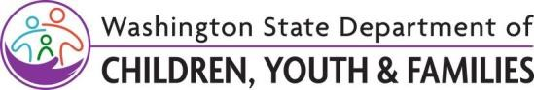

Agenda

DCYF Licensing Division-CPA Portal Learning & Listening Sessions
Date: Monday May 22, 2023
Time: 2:00-3:00 pm

Objective
The DCYF Licensing Division staff would like to communicate and collaborate with statewide CPAs to discuss the WA CAP - Binti portal, implementation supports, timeline, and training needs, and hear your questions relating to this process.

Agenda
Introduction and Welcome - Heather West 3 min Meetings are recorded.
WA CAP Communications – Deanna Sundby 5 min
Update on communication plans moving forward

Connecting the Dots Demonstration: Intake of a Family - Joelle Leisure and Shannon Ammons 10 min
Overview of the Migration Plan
Side-by-Side View of Process Map and WA CAP Joelle Leisure 15 min
Visual demonstration how the process map can help guide you through WA CAP, and an opportunity for questions.
Crosswalk of WA CAP Team vs WDT team: Roles and Responsibilities – Sarah Jackson and WDT X min
Presenters will provide an overview of the differences in the roles and responsibilities for each team and the supports they can provide
Question and Answer Session – WA CAP Team 10 min
This will be an opportunity for participants to ask questions to WA CAP support specialists
Updates on WA CAP Training Schedule and Roll Out – WDT Team 10 min
The LD-Workforce Development Team will provide an overview of the training schedule and important things to know as we get closer to training.
Closing - Heather West 2 min
Let us know if you have any topics you would like us to cover in our May 22nd meeting, which will be our final LD/CPA meeting before training begins.

*Please send feedback and questions to the portal inbox: dcyf.caregiverportal@dcyf.wa.gov
Original Date: May , 2023
Licensing Division | Approved for distribution by Jesse Byrd, Workforce Development & Training Administrator

